Experiment 10.2
Z-Transform and Inverse Z-Transform
Aim
Compute symbolic Z-transform and its inverse.
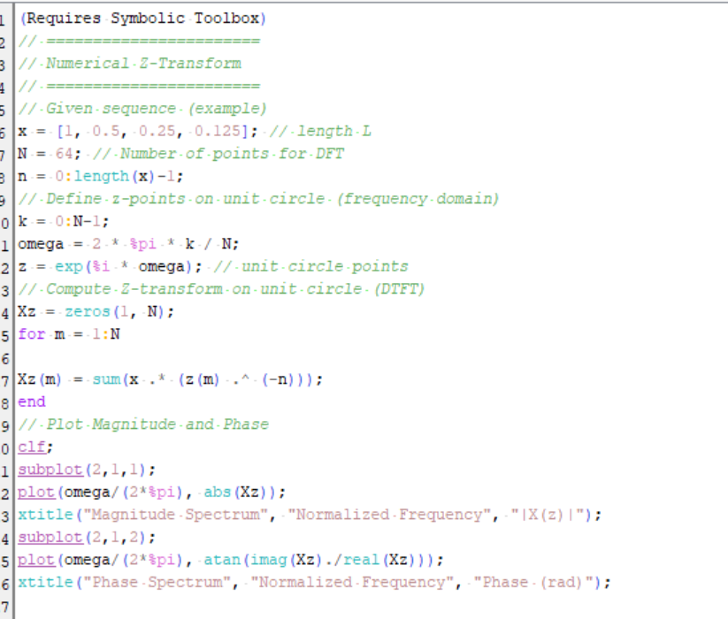
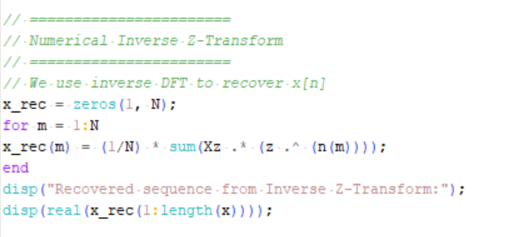
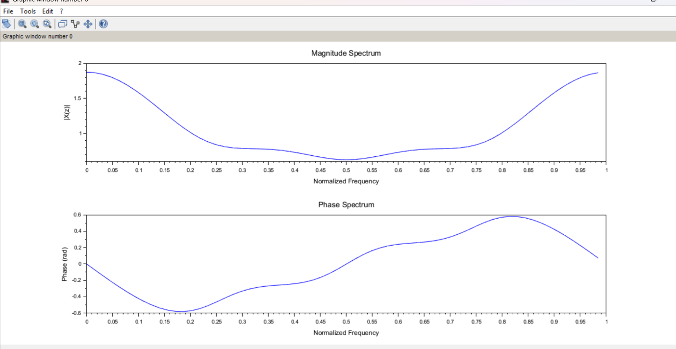

Experiment 10.4
Laplace Transform of Continuous-Time Signals
Aim
Compute Laplace transform of standard signals.
